SHOPSHERE ONLINE E-COMMERCE DATABASE MANAGEMENT SYSTEM
1.CUSTOMER ENTITY
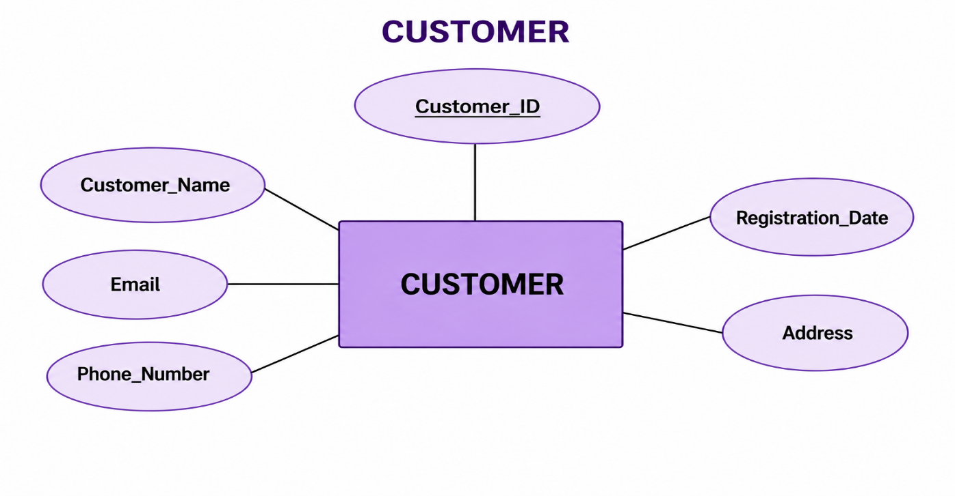
2.SELLER ENTITY
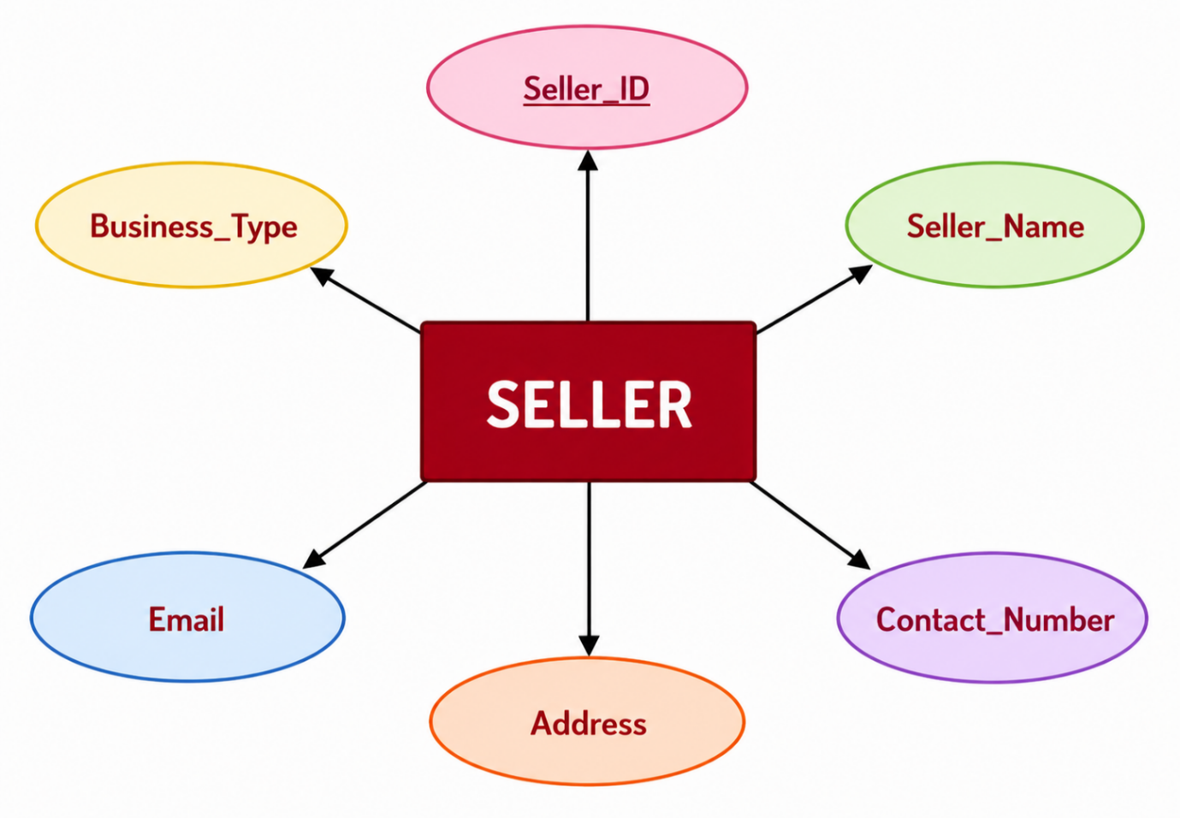
3. PRODUCT ENTITY
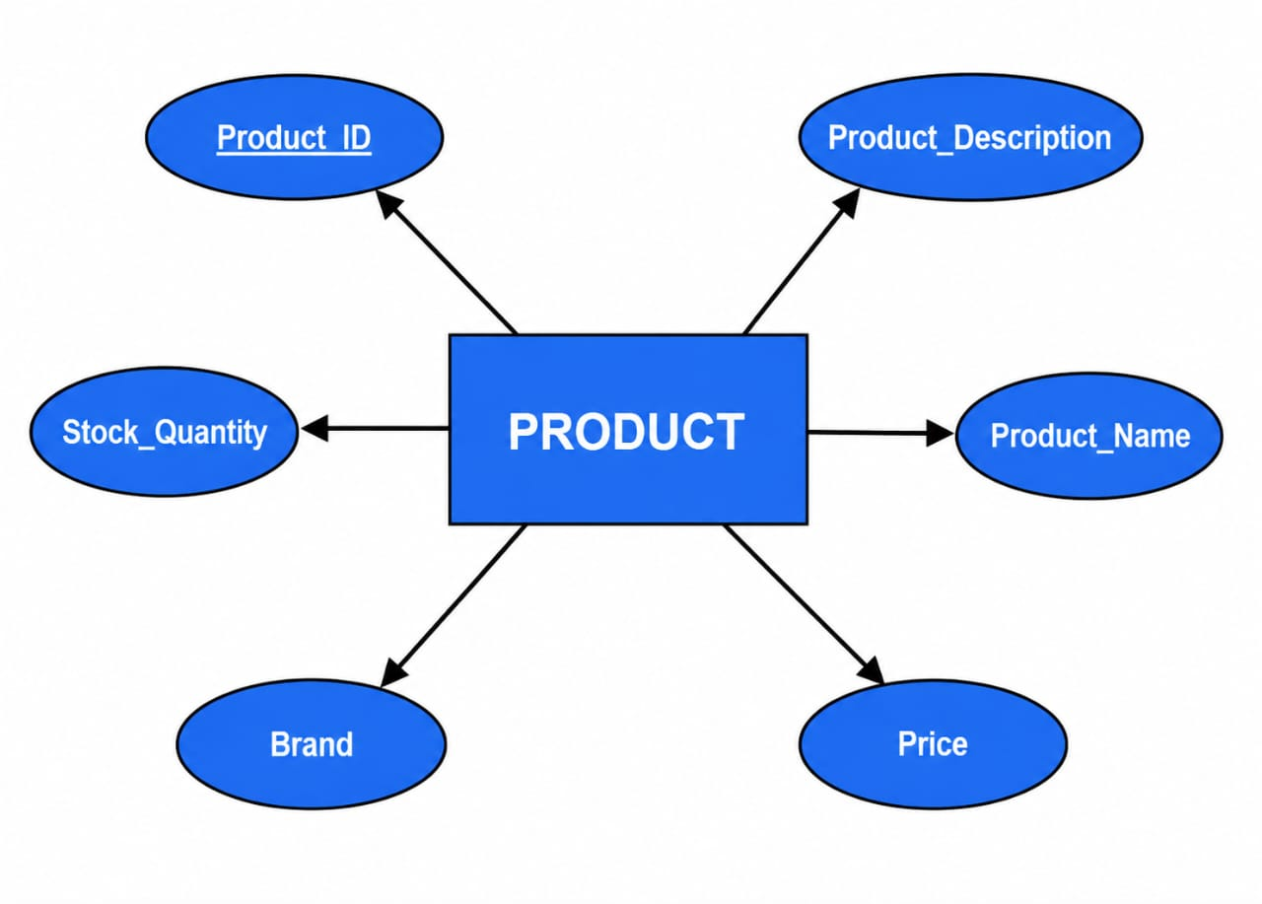
4.CATEGORY ENTITY
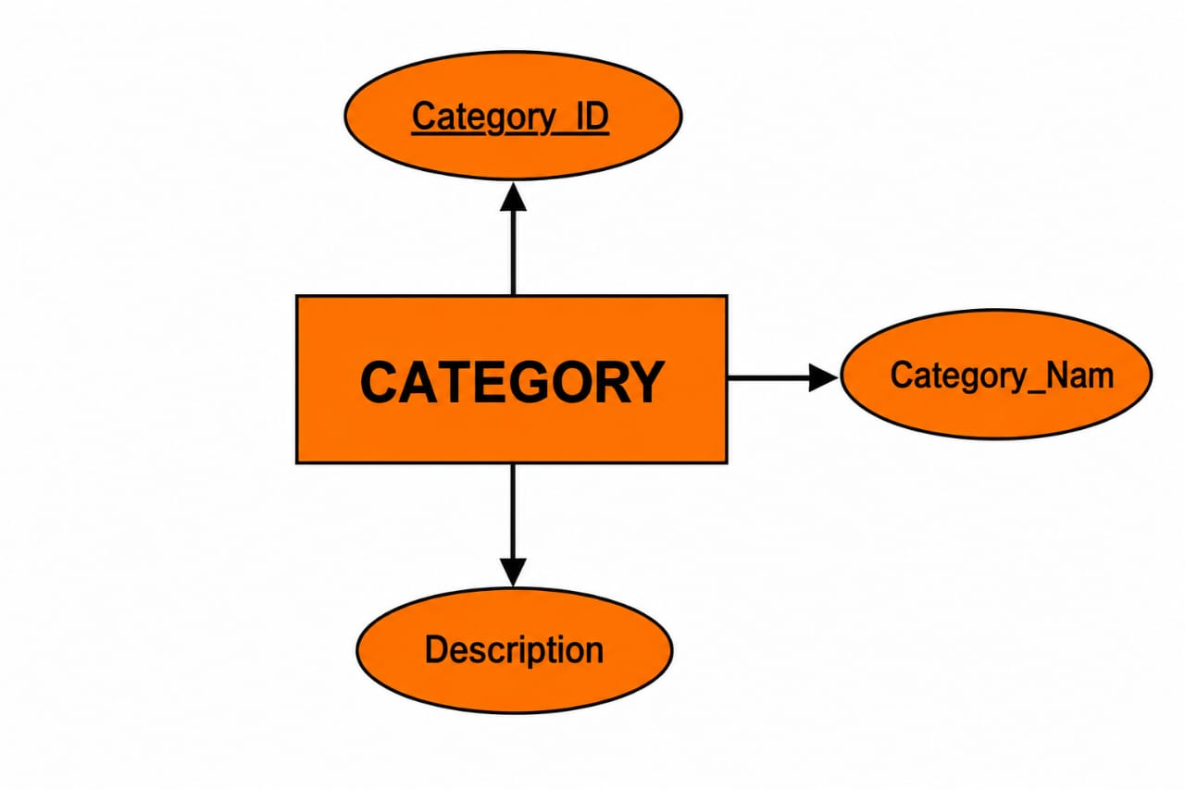

5.ORDER ENTITY
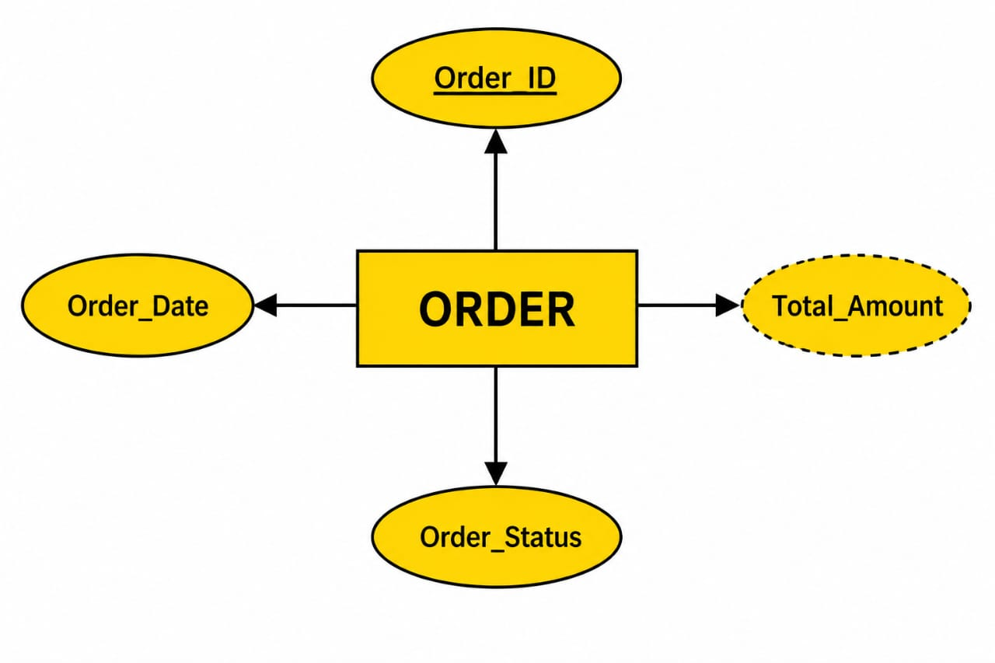

6.PAYMENT ENTITY
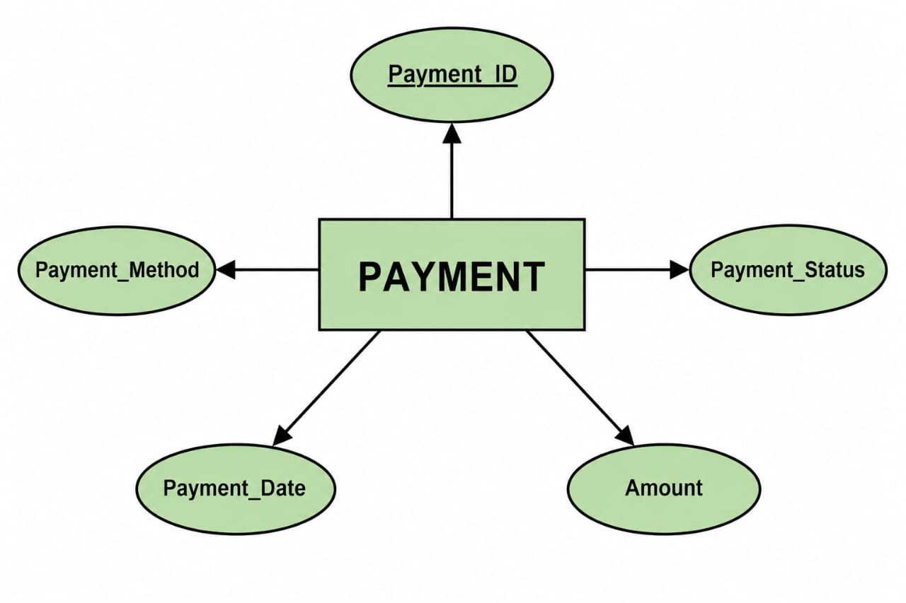
7.DELIVERY ENTITY
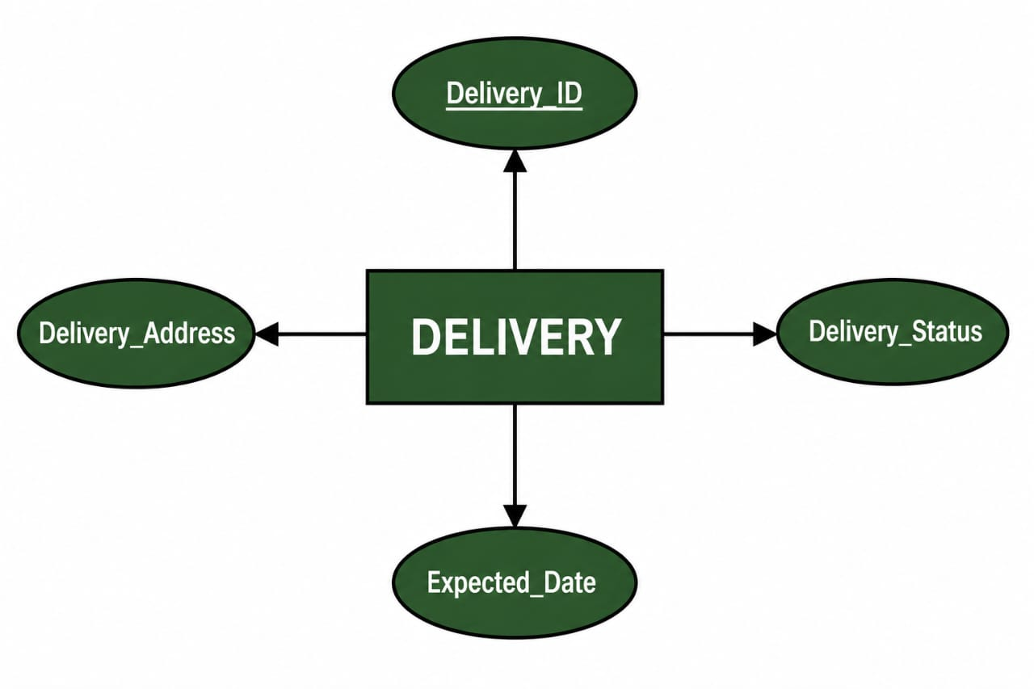

8.INVENTORY ENTITY
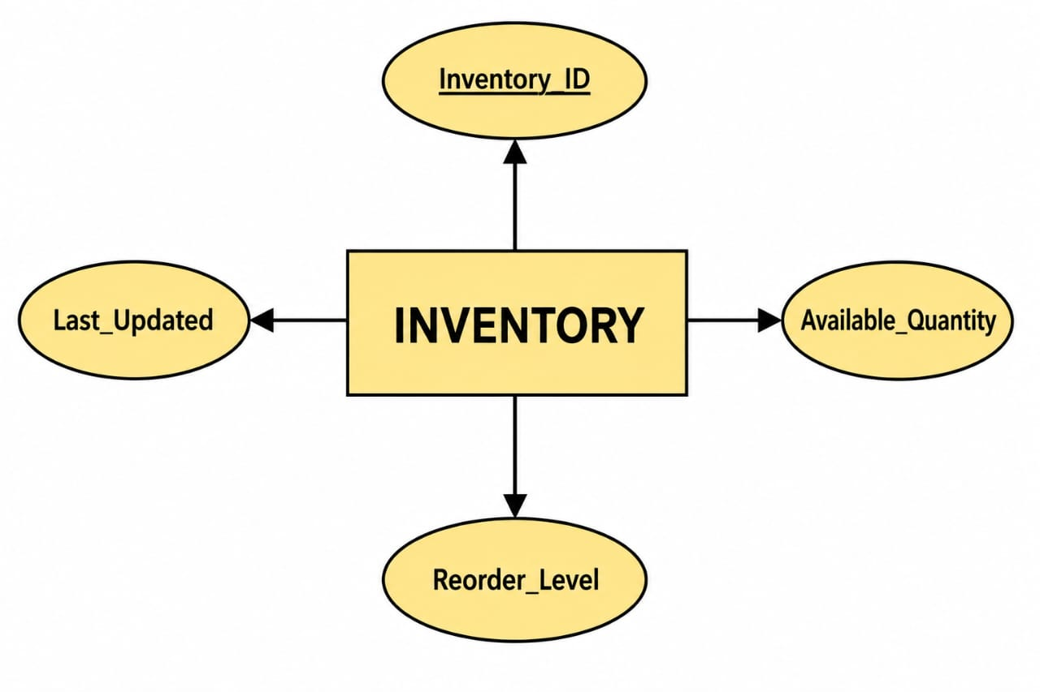

9.FEEDBACK ENTITY
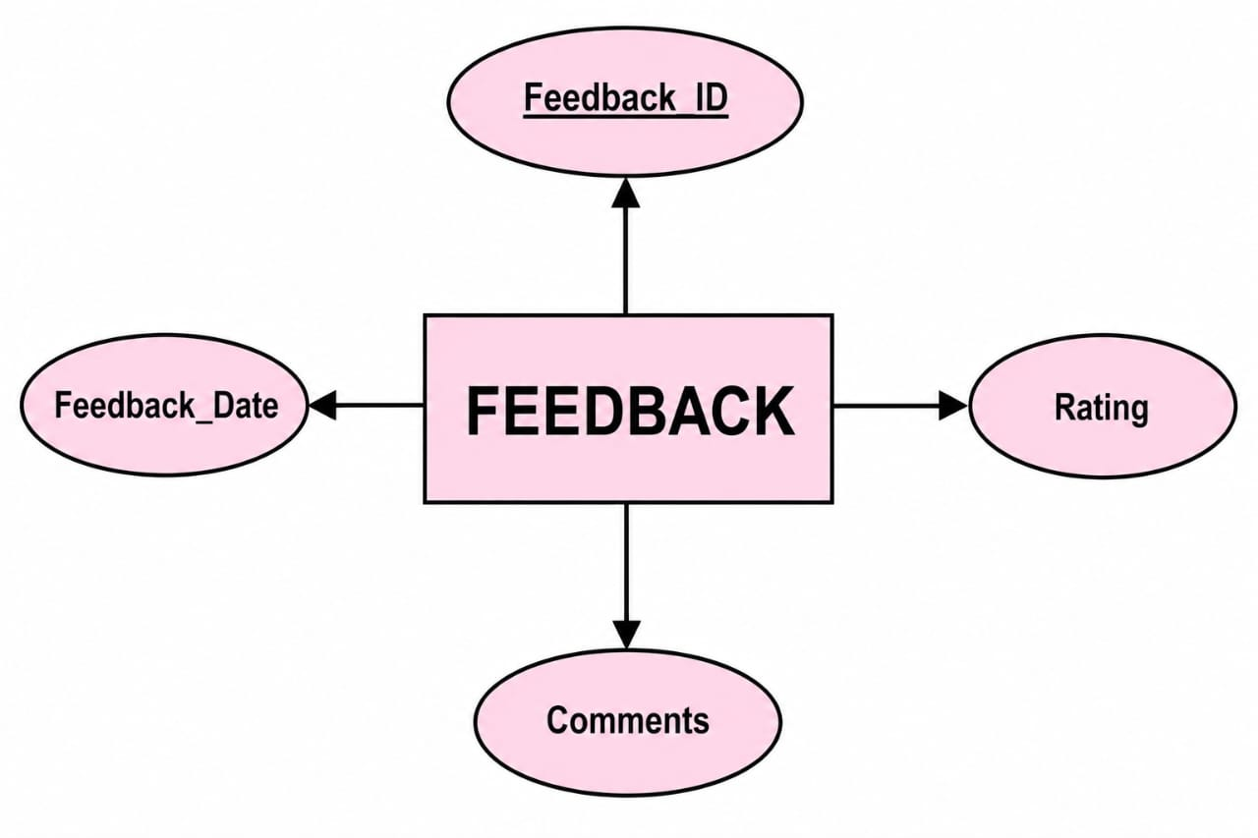

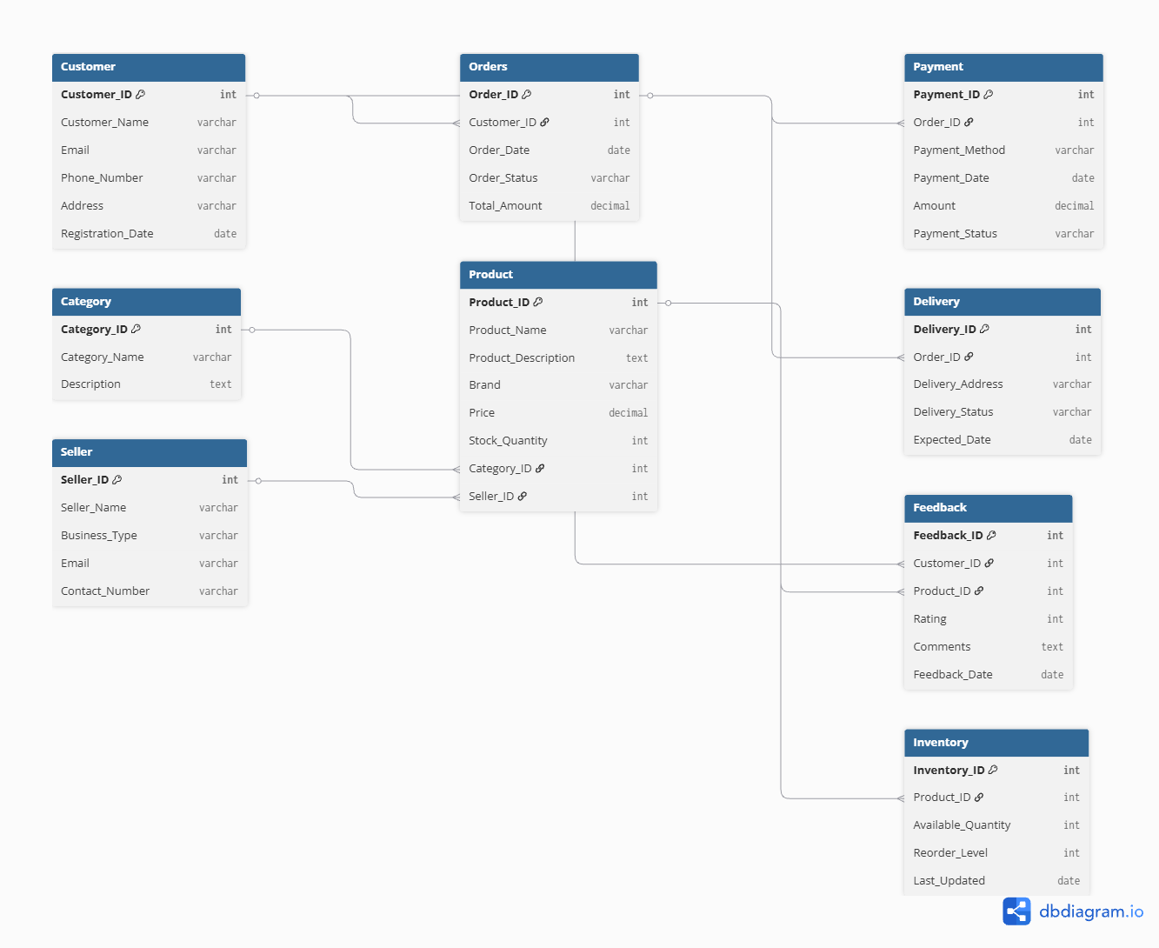

OVERALL DIAGRAM

